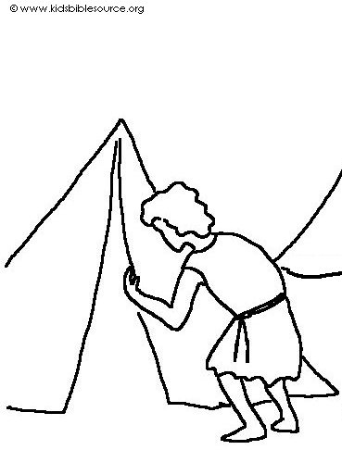
You may be sure that your sin will find you out. Numbers 32:23_{NLT}

